COMMUNIQUE
Council of Catholic Women Archdiocese of Detroit
Affiliate of the National Council of Catholic Women
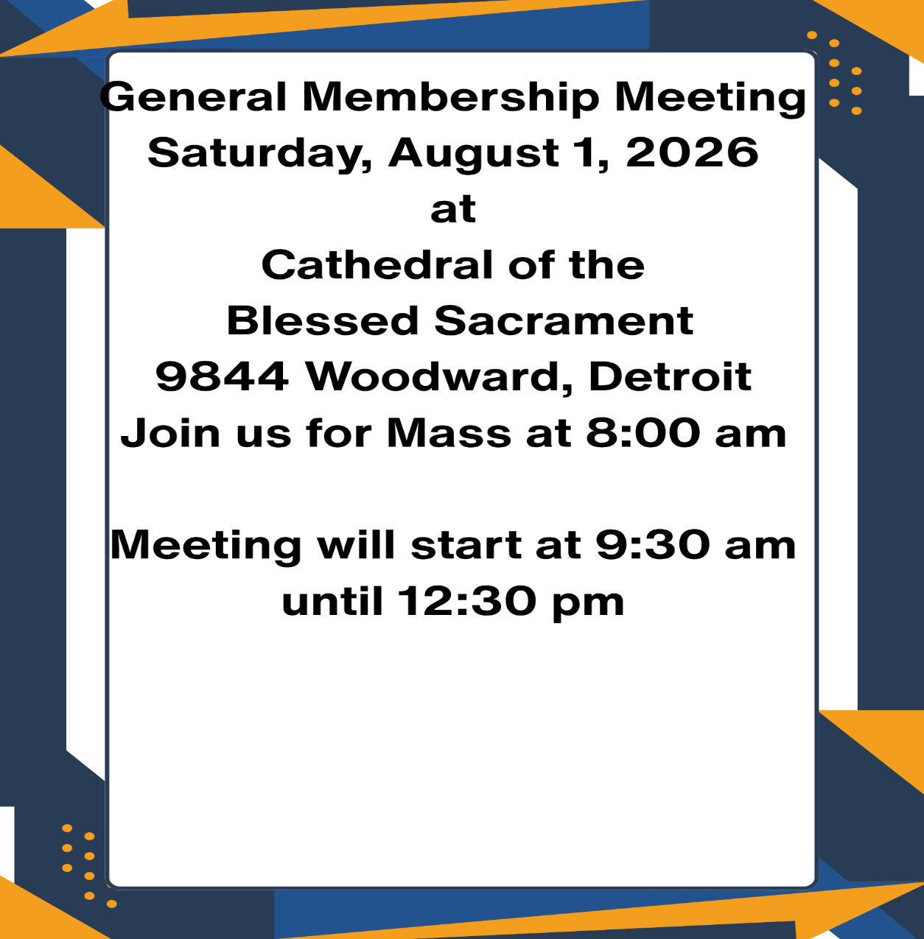
Guest Speaker Lt. Colonel Frank Roche
Please note date and location change

July 15, 2026
Council Commissions
Spirituality, Leadership and Service
Spiritual Advisor
Rev. Robert Blondell
Board of Directors
Pat Dery Kelly Vierk Rita Hill Lorraine McFee
Georgette Anders Kathleen Penno Jan Popowich

Leadership
President Pat Dery 586 524-7224
President Elect Kelly Vierk 313 377-3403
Treasurer Rita Hill 734 674-6121
Secretary Janet Brennan 734 626-3443

Service Commissions
Domestic Violence Joanne Nareski 734 281-4829
Hospitality Marsha Wisniewski 586 216-9962
Human Trafficking Georgette Anders 313 220-5172
Legislation Erica Makled 586 932-8987
Membership Lorraine McFee 313 563-1734
Mental Health Beverly Dubes 734 612-1599
National Liaison Kathleen Peno 586 772-1976
Operation Layette Jan Popowich 586 212-0434
Spirituality Judy Lambert 586 533-7536
Veterans Affairs Debbie Roche 248 435-4717
Website/Facebook Kelly Vierk 313 377-3403
International Concerns Carol Hofer 586 774-3144
Spiritual Advisor-Fr. Robert Blondell
Short Theology of the Mass
The Mass is the most important event of each week. We are called to the Altar by the Holy Spirit and its meaning is truly profound.
The Lord who calls is truly present. The Priest extends his hands over the bread and wine, invoking the Holy Spirit to effect the Divine presence of the Lord’s Body, Blood, Soul and Divinity. What does come down from Heaven also makes present His Passion, His Death, and His Resurrection. These mysteries are present and available on the Altar for us at every Mass. We are invited to enter these mysteries by eating and drinking His Body and Blood. In this way, we participate in His Passion, Death, and Resurrection.
We praise God for the grace to witness these mysteries and for the opportunity to share in them. Holy Communion is our entrance into these saving mysteries, made present on the Altar at every Mass.
Being mindful of this can deepen every celebration of the Eucharist. It certainly does for me, and I hope it will for you as well.
Sincerely and Faithfully,
Father Bob Blondell

FATHER BLONDELL, HAPPY 60TH ORDINATION ANNIVERSARY
&
HAPPY 85TH BIRTHDAY ON AUGUST 3RD

UPCOMING EVENTS
August 26 – 29 NCCW National Convention in Grand Rapids, MI.
September 12 Board Meeting, Cathedral of the Blessed Sacrament 10 am. 9844 Woodward Ave. Detroit Meeting Room A
October 10 General membership Meeting, Cathedral of the Blessed Sacrament 9844 Woodward Ave. Detroit Room B 10 am.
December 12 12 - 3 pm Annual Christmas Luncheon
Gazebo 31104 Mound Rd. Warren MI cost $40
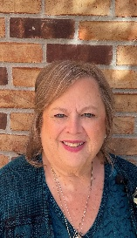 President-Pat Dery

A Heartfelt Thank You: Honoring Isabella Agby and Catholic Charities
As we look back on our recent successes and plan for the future, we are reminded that our community thrives because of the dedication, generosity, and hard work of incredible individuals and partners. Today, we want to shine a well-deserved spotlight on two pillars of our recent journey: our wonderful Communique editor, Isabella Agby, and our generous hosts at Catholic Charities.

Celebrating Isabella Agby: The Voice Behind the Communique
Putting together a newsletter is no small feat. It requires organization, a keen eye for detail, endless patience, and a genuine passion for storytelling. For her tireless efforts as our Communique editor, we owe a massive debt of gratitude to Isabella Agby.
Isabella has consistently gone above and beyond to ensure our community stays informed, engaged, and inspired. Through her dedication, the Communique became more than just a newsletter—it became a reflection of our shared values and achievements.

Thank you, Isabella, for your exceptional work, your creative vision, and the countless hours you spent behind the scenes bringing our stories to life. Your impact as a valued member of the Council of Catholic Women is appreciated

Deep Gratitude to Catholic Charities

A vibrant community also needs a place to gather, collaborate, and grow. We extend our warmest thanks to Catholic Charities for graciously opening their doors and allowing us the use of their wonderful facilities.
Having access to a welcoming, supportive, and well-equipped space made a world of difference for our meetings and operations. Catholic Charities’ hospitality is a true testament to their ongoing mission of service and community building.
We are incredibly grateful for their partnership and generosity, which allowed us to focus on our goals in a warm and collaborative environment. We appreciate the ongoing support we are receiving from them in the use of their facility at St. Lucy Parish in St. Clair Shores where Operation Layette is housed. It is a true blessing to have a dedicated space to house the many donations we receive to help the new moms with their babies’ needs. We look forward to a long partnership with Catholic Charities.

Looking Forward
It is because of dedicated leaders like Isabella and supportive organizations like Catholic Charities that we are able to continue our work with passion and purpose. Please join us in expressing our deepest appreciation to both of them the next time you see them!
More news from Me…..
We are making some great changes in our communication with our membership.
As you have noticed, the Communique is now being sent to you digitally by email and is more a “Newsletter” than a “magazine”. Those that do not have email will receive a mailed copy. The reasons are a couple, the most important is that we can get it to you faster, it is not “lost” in the mail, also, it saves us on printing cost.
Other changes you will see, thanks to our President-elect, Kelly, we will have a new presence on Facebook and Instagram. She is also setting up a new website, once the website is up you will be able to pay your dues via debit or credit cards and pay for any events that we will charge for (like the Christmas luncheon). Also, we will be utilizing our Gmail account more. Our Gmail address is ccw.aod@gmail.com, when you see an email coming from that address make sure you open it up!!
For our Affiliates who are collecting for the “Penny Pot”, we are disbanding the support of this organization, all funds collected will now go to Water for Life.
We would like to thank the Cathedral of the Blessed Sacrament for inviting us back to use their facilities for our meetings. We were there before for our meeting and because there was going to be a cost we found other places to meet. I guess they missed us because Father JJ invited us back, at no cost. So far the two meetings we have had there, they have been very gracious and welcoming.
I hope you will join us on August 1st for the 8 am Mass and then stay for our General Membership meeting at 9:30 am. We will have food and drinks available, and I look forward to hearing from our guest speaker, Lt. Colonel Frank Roche. Mr. Roche has worked with veterans and their causes for many years; it will be interesting to hear his stories and find out how we can help our veterans.
As you know things keep going up in cost, and unfortunately so do our expenses, The Board of Directors did have their meeting in June and voted to raise dues in 2027. We will be going from $15 to $25 for individual memberships. Affiliate membership and lifetime membership will stay the same. I am giving you the heads up now so you can budget it and be prepared. Anyone that may find this a hardship please reach out to me; we do not want a member to not renew because of cost. We value all our members and want to make sure that you also find value in being a member of CCW.
I look forward to reporting back to you in September what I experienced at the National Convention in August. I understand there are over 500 registered from across the country. I hope you can join us, even if it is just one of the days.
Peace of Christ be with you
Pat Dery, President 586 524-7224 pmd48082@yahoo.com

Come Grow With Us
The restructuring of our parishes does not mean a downsizing of our faith. Through the Council of Catholic Women, it can represent a season of great spiritual harvest.
If you are looking for a place to anchor your roots, share your gifts, and form lifelong bonds of sisterhood through this time of historic transition, the CCW has a seat waiting at the table for you. Together, we will keep the flame of faith burning brightly in southeast Michigan.

Anchors in Change: Why the CCW is Key to Membership Growth Amid Parish Restructuring
The Archdiocese of Detroit is currently navigating a profound structural shift. As we transition into new "pastorates" and realign our parish communities, many faithful are experiencing a mix of uncertainty and a deep longing for stability. In this environment, the Council of Catholic Women (CCW) is not merely an organization; it is a critical vehicle for stability, community connection, and membership growth.
As our regional spiritual landscape shifts, belonging to the CCW is one of the most strategic and life-giving decisions a Catholic woman can make.

1. Breaking Down New Structural Walls
Restructuring can naturally cause parishioners to feel isolated or separated from their long-term church homes. CCW operates beyond individual parish boundaries. By bringing women together from across the newly formed pastorates, the CCW serves as a ready-made bridge. It ensures that even if a woman’s physical place of worship shifts, her sisterhood in faith remains unbroken. This makes the transition feel less like a loss and more like an expansion of community.

2. A Welcoming Beacon for "Displaced" Faith Members
As parish communities merge, many people find themselves walking into unfamiliar pews. The CCW acts as an intentional welcoming committee. When a woman joins our council, she immediately gains an active network of friends, mentors, and faith partners. By offering this immediate sense of belonging, the CCW prevents people from slipping through the cracks of a shifting administrative framework, effectively driving membership retention and new growth.

3. Shared Focus Over Regional Frustration
It is easy to become caught up in the heavy logistics of church restructuring. The CCW redirects our focus outward toward what truly matters: Spirituality, Leadership, and Service. By involving new and existing members in impactful initiatives—like Operation Layette, combating human trafficking, and supporting veteran affairs—we provide a constructive outlet for service. Women are drawn to purpose, and the CCW provides a direct avenue to put Gospel values into immediate action.

4. Supporting Our Pastors as "Mission-Ready" Leaders
With fewer priests managing larger, grouped pastorate communities, our clergy are under immense pressure. The CCW answers the Archdiocese’s call to build a "Mission-Ready" Church by stepped-up lay leadership. We empower women to take ownership of administrative, charitable, and spiritual ministries. When pastors see a thriving, organized council capable of absorbing and uniting women from multiple combined parishes, it eases their burden and strengthens the overall health of the entire local church.
"The double circle in our official CCW-AD logo represents the never-ending circle of needs to be met by an inclusive circle of volunteers. Right now, our Archdiocese needs that unbreakable circle more than ever."

International-Carol Hofer
Our era is a tough puzzle...the best of times and the worst of times, to paraphrase Charles Dickens. It is too much to consider. Fabulous wealth mocking excruciating poverty. Corporations growing fat and prosperous by making weapons that leave devastation and death in their path. Buildings toppled and crushed during war, with human bodies left to rot beneath them. The "worst of times" is too real for some.
Medical and scientific achievements unimaginable a few generations ago give hope and relief to millions. But others, the poor, often have no access even to inhalers or antibiotics, vaccines, or clean water or food costing so little by comparison. There are people in this world who simply don't count.
Technology can be used to make astounding contributions to the common good. They can be used to promote evil as well. Consider the young women and men and children who this night will be forced to perform unspeakable sexual acts and suffer violation and desecration of their bodies and spirits while their "customers" are pleasured. Or perhaps the "customers" go to their computers and with a few clicks order live videos of sexual torture, humiliation and more.
It is incomprehensible. What do we do as followers of the gospel? Pray, support those doing good. Fight back the night. Advocate for just laws. Be creative with ideas to assist those needing help no matter where on Earth they reside. You have heard the saying "When a butterfly flaps its wings the effects are felt on the other side of the Earth." Yes, we are all connected.
Hope and promise still exist. How gratifying to realize that in this world of complexities and injustice there are people making a stand against evil and injustice. Yes, they are fighting back the night. Among them and sometimes leading the charge are those nurtured by the gospel of Jesus. Consider the accounts given by the Global Sisters Report. The kind of life-giving work accomplished here in our country in Jesus' name is also being done around the world. Inspiring stories are endless. Nuns in Nigeria take in pregnant girls and elderly persons abandoned by their families, striving to make their lives more promising. A group of sisters from the Philippines follow the spirituality of St. Charles de Foucauld by living and working with ordinary people of the poor classes. The sisters take jobs in factories and bakeries and farms, assisting others where they can, pressing for just wages for all, accompanying the poor on their journey, witnessing to the gospel.
In Kenya a devoted priest and Catholic lay missionaries, several from right here in metro Detroit, are managing an orphanage for little ones with no families and no place to go. Three Indian teenagers are devising new ways to purify drinking water of bacteria and microplastics. Scores of volunteers from various countries and various religious traditions--especially the Roman Catholic tradition--are working here in this country and in countries all over the planet to educate and heal, or to preserve the environment, to bring water to the thirsty, to feed victims of war or famine, to build peace instead of violence.
This is the Universal Church at work. Be a part of it.

Mental Health Ministry- Lorraine McFee
Would you value joining others in a conversation about mental health? Would you like to discover what God, Scripture, and Church have to say in light of the experiences of mental health challenges?
The Sanctuary course for Catholics is an eight-part course for small groups designed to raise awareness and start conversations in local parishes regarding mental health. It was created in collaboration with Catholic mental health professional, theologians, and clergy, and offers faith communities the opportunity to learn about mental health and grow in their ability to support members living with mental health challenges.
For more information you can contact Lorraine McFee at 313 563-1734 or email her at sweetlor@earthlink.net or Tom Smith at 734-771-8103 or email him at tomsmiyh-613@gmail.com.

Human Trafficking - Georgette Anders
The Most Recent Published Statistics from the National Human Trafficking Hotline:
Human trafficking is a form of modern slavery that occurs in every state, including Michigan. The NHTH (National Human Trafficking Hotline) works closely with service providers, law enforcement, and other professionals in Michigan to serve victims and survivors of trafficking, respond to human trafficking cases, and share information and resources.
The Human Trafficking Hotline has received 10,930 signals since its inception (2007).
Hotline Call: 8,662
SMS Report (Text Message): 999
Online Report: 859
Email Received: 250
Web Chat: 160
Since its inception, the Human Trafficking Hotline has identified 3,307 cases of human trafficking. 6,909 victims were identified in these cases.
Michigan Cases Only:
Signals Received in 2024
Signals received by the Hotline in 2024 764
Signals received from victims or survivors of human trafficking 219
Referrals 3
Other 761
People can contact the Hotline by phone, text, online chat, online form, and email. Most people contact us by phone or text.
Signal Types:
Hotline Calls 506
SMS Reports 105
Online Reports 87
Web Chats 42
Emails Received 24
Types of Trafficking
Sex 216 Labor 38 Sex and Labor 27
Venues for Sex Trafficking
Residence-Based Commercial Sex 31
Hotel/Motel-Based 27
Illicit Massage/Spa Business 3
Online Ad Venue Unknown 6
Escort/Delivery Service 6
Pornography 5
Street-Based 4
Hostess/Strip Club-Based 3
Other 133
Venues for Labor Trafficking
Domestic Work 9
Agriculture/Farms 5
Restaurant/Food Service 4
Retail/Other Small Business 4
Illicit Activity 3
Hospitality 3
Other 13
Requests on Human Trafficking Cases
Report a Trafficking Tip 204
Access Service Referrals 122
Request Crisis Assistance 11
Request General Information 3
Ages Sex
Adults 243 Females 266
Minors 68 Males 34

The National Human Trafficking Hotline is supported by the Administration for Children and Families (ACF) of the United States (U.S.) Department of Health and Human Services (HHS) through a financial assistance award totaling $7 million annually.

OPERATION LAYETTE (OL) QUARTERLY MEETING REPORT – Jan Popowich
July 2026
This quarter, a total of 128 layettes were made and distributed. Of those 4 went to a distribution center to aid northern Michigan flood victims and 4 were distributed through the MI Dept of Health and Human Services. In addition, 4 gently used pack and plays were donated to the flood victims, we purchased 2 highchairs for the foster mom of twins and 2 new cribs for the custodial grandmother of expected twins. We also gave her a used mattress that was donated to us. 1 case of size 5 diapers was purchased for a NIN from SIJ St Vince. We placed an ad in Gianna House’s Casino Night fundraising program.
Baby items and monetary donations were received through the following: Mission Ladies of the Little Flower St Mary Cause of our Joy Christ Child Shower St Linus Baby Shower Our Lady of the Angels Shower Our Lady of LaSalette Baby Bud Tree donation drive St John Vianney Women’s Club Shower St Alfred’s Parish donation drive
Hand-made baby items were donated by The St Paul Sewers, the Metro Detroit Quilters Guild, St John Vianney’s Stitchers in Faith, St Therese of Lisieux Circle of Friends Sewers and the Clinton Township Retired Senior Volunteer sewers. Thank yous are always sent after donations are received.
Committee members meet to put together layettes on the second Tuesday of the month and layettes are picked up by the distributing agencies on the third Tuesday of the month. Members get together to unpack and sort donations as needed.
Baby items are purchased as needed to fill in the gaps when such items are not received in donations. This quarter, diaper rash cream, baby shampoo, and bath towels were purchased.
Heart of Christ Family Services has changed locations and because of a staffing change, they are no longer able to pick up layettes but still need them. They are now housed in the Project Hope facility which is on Porter Street in the Corktown area. If anyone is able to pick up 10 layettes from St. Lucy’s and deliver them on a Monday morning, please let me know. Help would be appreciated.
Our goal for the remainer of 2026 is to continue to be able to distribute layettes as we have and to always seek out agencies or individuals who may need a layette or two. There are always a few extra layettes available for someone in need.

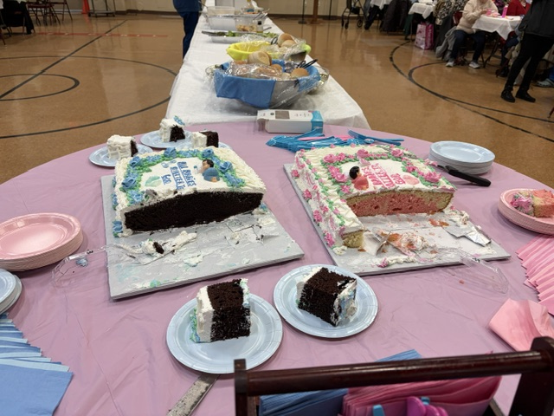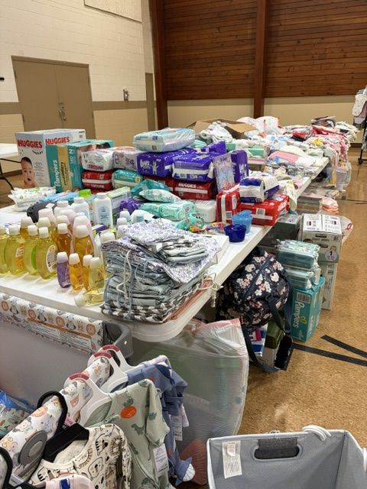
Our Lady of the Angels baby shower Our Lady of the Angels
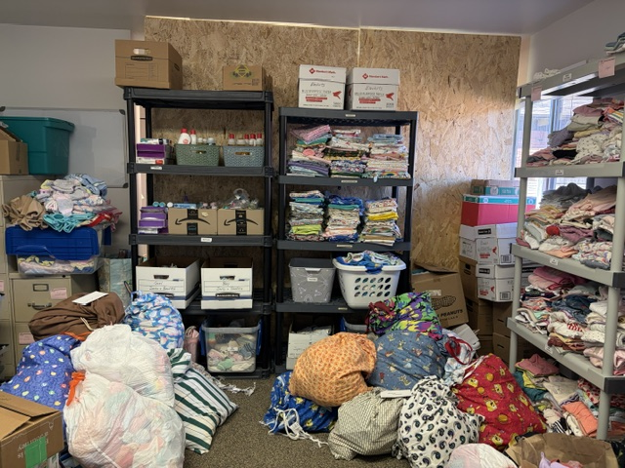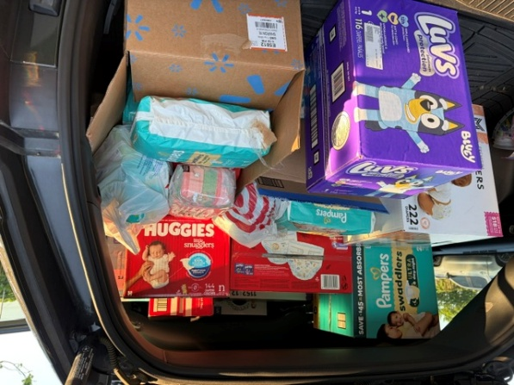
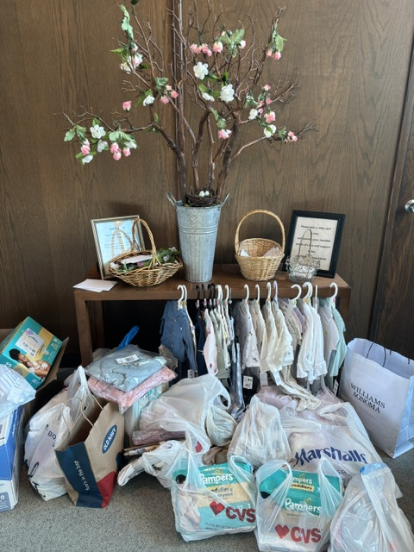
After Spring Baby Showers, are shelves are full! Thank you, St Alfred’s, for all the diapers!

Our Lady of LaSalette Baby Bud Tree donation drive
Veterans Affairs – Debbie Roche
The VA is seeking two to three volunteers each weekday morning from 8 to 10 am to bring a little joy our veterans – and all it takes tis five dozen doughnuts and willing heart. If you would like to participate, contact Camille Randle, Volunteer Services Specialist, to find available dates. Call 313 576-3332 or Camille.randle@va.gov
S.O.A.P Project
August 8th at Rosedale Gardens Presbyterian Church 9601 Hubbard, Livonia 48150 10:00 am to 12:00 pm. Join them as they reach local hotels to raise awareness of Human Trafficking in the area. The SOAP project work to raise awareness of human trafficking through hotel outreach volunteer engagement and education. For more info reach out to Theresa Flores at info@soapproject.org

Water for Life and The Madonna Plan
CCW supports several charitable projects. Two such projects are Water for Life and The Madonna Plan. Both charitable projects are global initiatives run by the National Council of Catholic Women and Catholic Relief Services.
Water for Life was established in 1978 to support the availability of safe and clean water. This organization supports the building of strong communities by supporting irrigation projects, sanitation systems and hygiene education. One in ten people in the world do not have access to a safe water supply. Water for Life supports projects that reduce disease, improve agricultural viability, and offers disaster relief.
The Madonna Plan empowers women and children in impoverished regions through healthcare, education and financial security. Since 1958 the Madonna plan has supported families working with pregnant women and children providing vaccinations, nutritional education and hygiene programs. The Maternity without Risk program reduces maternal mortality by providing services and education to prevent delivery complications.
At the August general meeting CCW will provide the opportunity to donate to one or both of these charities. Local affiliates are also encouraged to support a collection within their parishes to raise donations for these compassionate charitable organizations.
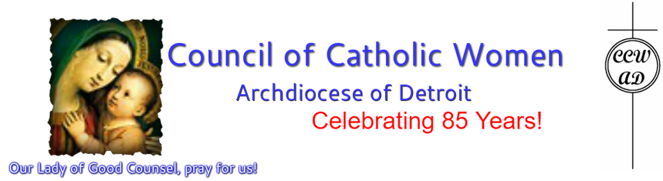

The Council of Catholic Women
PO BOX 100
Dearborn Heights, MI 48127

Please send any content suggestions or articles to Georgette Anders at gander3559@gmail.com

The Communique will be a quarterly newsletter, out in January, April, July and October
Articles for the next Communique are due by September 15, 2026
Next Communique publication will be out in October 2026

